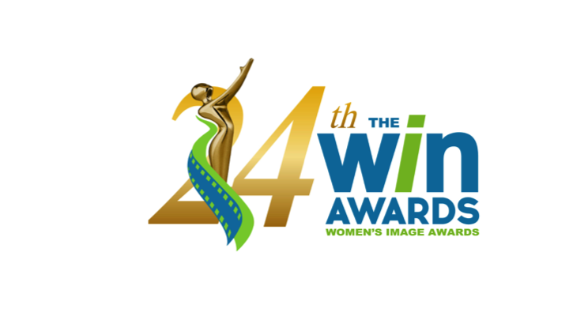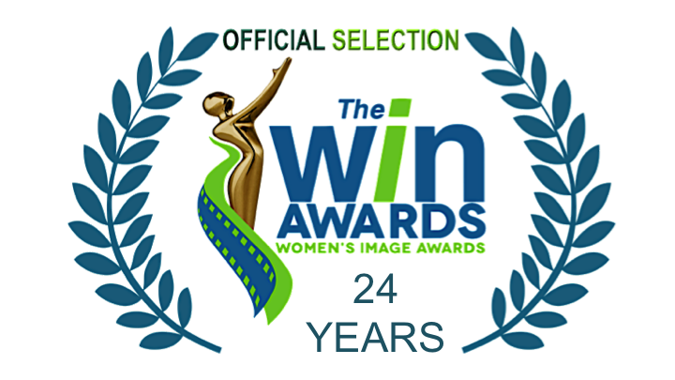

FOR MORE INFORMATION
Publicity Contact: Joy Tuttle 310-229-5365 Info1@TheWINAwards.com

* * * * FOR IMMEDIATE RELEASE * * * *

WOMEN’S IMAGE NETWORK ANNOUNCES ITS CO-HOSTS & NOMINEES
The 24th Women’s Image Awards Co-Hosted by Emily Vogel and Andi Ortiz
Presenting 15 Outstanding Film and Television Awards
* * * *

November 1, 2022 (Los Angeles) Now in its 24th year, The Women’s Image Awards celebrate male and female media artists who create dimensional female media images, which also advance positive public opinion about the value of women and girls. The Women’s Image Awards ceremony is Thursday, November 10, 2022 in at the glorious Wilshire Ebell theatre. Co-Hosted by Emily Vogel and Andi Ortiz (of The Wrap and “UnWrapped” podcast). Says WIN founder, producer, Phyllis Stuart, our co-hosts are two engaged, young women who will help WIN celebrate outstanding media that increases the value of women and girls.”

WHAT: The Women’s Image Awards 24
WHERE Wilshire Ebell Theatre 4401 W 8th St, Los Angeles, California
WHEN Thursday November 10, 2022 RED CARPET 6:30PM / Ceremony 8PM

The Women’s Image Awards 24 film and television nominees:
Documentary Film
Who Is Ghislaine Maxwell? (Starz)
Introducing, Selma Blair (Discovery+)
Janet Jackson (Lifetime)
Dream On (ESPN)

Made For Television Movie / Limited Series
Gaslit “Will” (Starz)
Zoey’s Extraordinary Christmas (The Roku Channel)
1883 “Season 1, Episode 1” (Paramount+)
List of a Lifetime (Lifetime)

Actress Made For Television Movie / Limited Series
Julia Roberts Gaslit “King George”
Faith Hill 1883 “Racing Clouds”
Isabel May 1883 “The Weep of Surrender”
Betty Gilpin Gaslit “Tuffy”

Drama Series
P-Valley “Mississippi Rule” (Starz)
The Cleaning Lady “TNT” (Fox)
(more)

Hightown “Great White” (Starz)
Power Book III: Raising Kanan “Back In The Day” (Starz)

Actress Drama Series
Patina Miller Power Book III: Raising Kanan “Paid In Full”
Natascha McElhone Halo “Solace”
Caitríona Balfe Outlander “Sticks and Stones”
Shannon Thornton P-Valley “White Knights”

Comedy Series
Shining Vale “Chapter 8 - We Are Phelps” (Starz)
Hacks “I Think She Will” (HBO MAX)
Welcome to Flatch “RIP Cynthia” (Fox)
Home Economics ”Camping Tent $39.99” (ABC)

Actress Comedy Series
Courteney Cox Shining Vale “Chapter 8 - We Are Phelps”
Jean Smart Hacks “I Think She Will”
Mira Sorvino Shining Vale “Chapter 8 - We Are Phelps”
Holmes Welcome to Flatch “That Old Flatch Magic”

Animation Program
HouseBroken “Who’s A Bad Girl? Part 2” (Fox)
It’s Pony “Saving Horse” (Nickelodeon)

Actress Animation Program
Lisa Kudrow HouseBroken “Who’s A Bad Girl? Part 2”
Jessica DiCicco It’s Pony “Saving Horse”

Reality Series
Love On The Spectrum “Episode #2.6” (Netflix)
Why Not Us Southern Dance "It’s Showtime, Boo" (ESPN)

Drama Series Writer
Tash Gray Power Book III: Raising Kanan “The Cost of Business”
Toni Graphia Outlander “The World Turned Upside Down”
Rebecca Cutter Hightown “Great White”
Katori Hall P-Valley “White Knights”

Comedy Series Writer
Emily Schmidt Welcome to Flatch “On The Hooky”
Julieanne Smolinski Home Economics “Camping Tent, $39.99”
Jenny Bicks Welcome to Flatch “RIP Cynthia”

Show Producer
Miranda Kwok, Melissa Carter The Cleaning Lady “TNT”
Nikki Toscano The Offer
Jennifer Flanz The Daily Show with Trevor Noah “Season 27, Ep. 87”
Rebecca Cutter Hightown “Great White”

Scripted Show Director
Ryan Case Home Economics “Camping Tent, $39.99”
Monica Raymund Hightown “Fresh As A Daisy” (more)

Christina Alexandra Voros 1883 “The Fangs of Freedom”
Alethea Jones Shining Vale “Chapter 5 - The Squirrel Knew”

Non-Fiction Show Director
Dawn Porter 37 Words “Part 1”
Kristen Lappas Dream On
Nicole Newnham 37 Words “Part 4”
Allison Glock Home Field

About Co-Hosts
Emily Vogel is on a mission to promote the entertainment and media industry. Serving as the Director of Programming at TheWrap, Vogel is responsible for overseeing content, programming and talent relations for the company’s full line-up of events, including TheGrill conference and Power Women Summit (PWS). For more information about PWS 2022 (December 13-14) visit www.thewrap.com/pws

Vogel also oversees the WrapWomen brand, a power base of influential women who are committed to changing the face of their industry. Her success led her to host produce the “UnWrapped” podcast for TheWrap alongside Andi Ortiz, which is dedicated to empowering the next generation of women in Hollywood. The series features interviews with leading industry heavyweights who take audiences behind the scenes of their latest projects and share their best career advice. Additionally, Vogel also writes and curates the WrapWomen newsletter and runs the WrapWomen blog.

Andi Ortiz co-hosts of the TheWrap’s “UnWrapped podcast with Emily Vogel, covering all things nerdy in movies and television. She’s determined to connect audiences to their favorite stories and characters, and have some fun along the way. Andi also co-hosts WrapWomen’s "UnWrapped" podcast alongside Emily Vogel, dedicated to empowering women within the industry. Previously, Andi worked in radio, because for better or worse, she's always been pretty good at talking to strangers. When she's not working, you'll probably find Andi hanging out with her dog and eating pizza (don't worry, he's only been successful at stealing that pizza once).

About The Women’s Image Awards
To advance the value of women and girls, since its 1993 founding by actor and filmmaker, Phyllis Stuart, (Wild Daze, Becoming Bert Stern), Women's Image Network, (WIN), has produced The Women's Image Awards to celebrate artists whose work depicts dimensional female media images. ​

For tickets please email Asst1@TheWINAwards.com or call 310-229-5365.

#####

